ACURRICULUM VITAE

Nianbo Peng

PERSONAL DETAILS
Nationality : Chinese
Date of Birth : 08/ 1977
Job function : Industrial Inspector
Base City : Wuhan city, Hubei Province

EDUCATION
1996.09 - 2000.07 Jianghan Petroleum institute
Bachelor of Engineering, Major: mechanical manufacturing process and equipment

CODES, STANDARDS AND SPECIFICATIONS | Experienced with the following codes, standards and specifications:  API676, API 682, ISO9906, GB/T3216, API6D, API598, API11AX, API610, ISO5199, ISO9906, API598, ASME II, ASMEV, ASME VIII, ASME IX, ASME B16.5, ASME B16.10, ASME B16.47, GB150 and other clients’ specifications, and other clients’ specifications.
COMPUTER SKILLS | Knowledge of major MS Office software applications, including Word, Excel, Project and PowerPoint, very familiar with E-mail communications and Internet.
TRAINING CERTIFICATES: | CWI  ASNT RT, UT, MT, PT level Ⅱ
COMMODITY SPECIALISM: | Centrifugal pumps, PC pumps, pressure vessels, valves, compressor, heat exchanger, piping and fitting, fiber glass and rubber lining pipes and vessels; other fluid equipment as RO skids, UF skids; instruments as flowmeter, dynamical equipment and machine
SUMMARY OF PROFESSIONAL EXPERIENCE:

- Project 1: GHAENAT STEEL MAKING PLANT (2021.3-2021.9)
- Project 2: ExxonMobil JV Offshore Platform （2021.5-2021.9）
- Project 3: INVISTA Nylon 6, 6 Phase III China ADN Project CT 2020.4-2021.4
- Project 4: SNCTL 4Mt/a Coal to liquid project package, Ningdong town, Yinchuan City, Aug 2015 to Aug 2019
  - Project 5: China coal tuke town coal chemical project, Edors, Inner Mongolia, Aug 2015 to May 2021 (phase II, III)
  - Project 6: China shenhua coal based new material project, Urumqi, Aug-Nov 2015
  - Project 7: KOC Lower fars heavy oil development program phase -1 (60MBOPD) (2017.6-2021.7
  - Project 8: Continental gold mine water treatment system Buritica, Colombia (2019.5.2021.4)

Aug /2015-now
Position: Senior inspection leader
Responsibilities
- Performed the resident or surveillance inspection on behalf of client.
- Document review, such as MPS, ITP, raw material certificate, personnel qualification and relate certificate, NDT qualification, equipment certificate etc.
- Document review for procedure such as welding, NDT, pressure test etc.
- Raw material inspection, including visual quality, quantity, dimension, lab test for raw material.
- Welding check as per drawings and WPS and check welder qualification.
- Witness heat treatment. Chemical and mechanical properties test
- Visual and dimensional check.
- Witness NDT / review NDT document.
- Assembly inspection,Function test，
- Witness hydrostatic test.
- Surface preparation, SS pickling & passiviation, painting and coating inspection.
- Check packing & marking.
- Loading supervision.

April /2014.6-Aug/2015
Position: Inspection leader
Project: RUMAITHA/SHANAYEL FACILITIES PHASE III PROJECT:
Product: Steel pipe
Material: API X52,X65, P110
This is an oil pipe (SMLS, tubing, casing) project in TPCO, as the project leader, my job as below
- Attend the kick-Off meeting and pre-inspection meeting, review the MPS and ITP, get agreement on the inspection details with both the mill and the owner
- Perform the quality system audit to the mill according to API Q1 with the clients, report the finding to the client. Follow up the corrective action and the result, report to the client
- Perform the daily in-site quality control as hot rolling, heat treatment, NDT (UT, MT, and PT), pressure test, dimensional, threading, coating, packing and shipment
- Coordinate with the mill for the quality inspection and manufacturing schedule. Ensure that the workshop implement the MPS
- Witness the material test as chemical analysis, mechanical properties test, HIC, SSC
- and CTOD, record the test information, ensure that only qualified product can be release to the next process.
- Provide the client with needful information as the production statues, quality control; Review the MTC, packing list, and the test report. Review the CAR and confirm the corrective actions in site, Release the shipment accordingly
- Collect the quality information and issue the daily inspection report to the owner’s management, give feed-back for their queries. Continues improve our inspection to meet the owner’s requirements.
2006-2014.6
Weatherford Energy Co., Ltd
Position: QC engineer
Project: varies oil field equipment of weatherford (as below)
- Perform the inspection for the raw materials that will be used for our parts, confirm that the billets meet the WFT specifications as chemical and mechanical & NDT
- Supervise classify the billets into different grades in case of any confusion on the billets grade during the machining
- Audit the subcontractors, the wrought as heat treatment, carburization, forging, perform the in-coming inspection for the wrought parts, what can help to reduce the ratio of scrap
- Perform the daily field inspection for the spare parts, ensure that welding and machining process can meet the WFT specification and international standard as API 5B, API-11B, API-11AX
- To confirm the MTR and the original test and measurement report as dimension inspection, chemical and mechanical and NDT inspection, issue the inspection and traceability monitoring report to weatherford overseas quality department
- Seasonal suppliers audit in according to API Q1
Project 1: Weatherford PC pumps inspection
Project 2: Weatherford pumping unit inspection
Project 3: Weahterford suck rods and coupling inspection
Project 4: Quality management system audit—API-Q1

2000/9-2006/3
Position: QC engineer
Product: artificial lift equipment and spares:
- Follow the production in the mills, communicate with PMs, APMs, Shift Leaders Inspector to collect all data of production.
- Make statistic on the data of production, prepare production report and send it to Production Manager, QC Manager, Logistics Dept, management of the company headquarters.
- Perform the daily in-site quality control as hot rolling, heat treatment, NDT (UT, MT, and PT), pressure test, dimensional, threading, coating, packing and shipment
- Coordinate with the mill for the quality inspection and manufacturing schedule.
Project Involved:
CSST project (2000.9-2006.2)

COPY OF QUALIFICATIONS
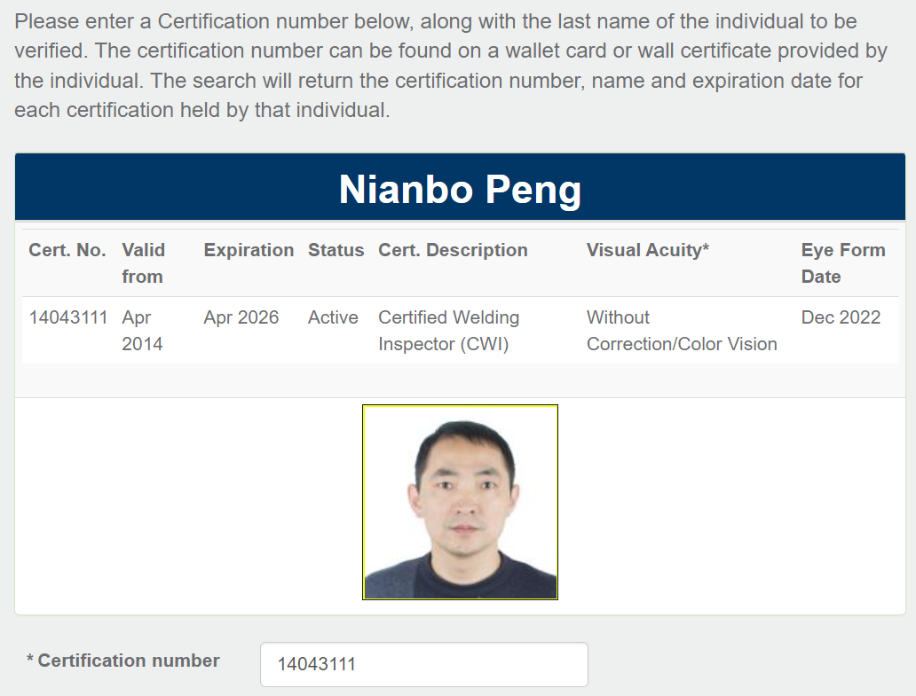
ASNT UT, RT Level II
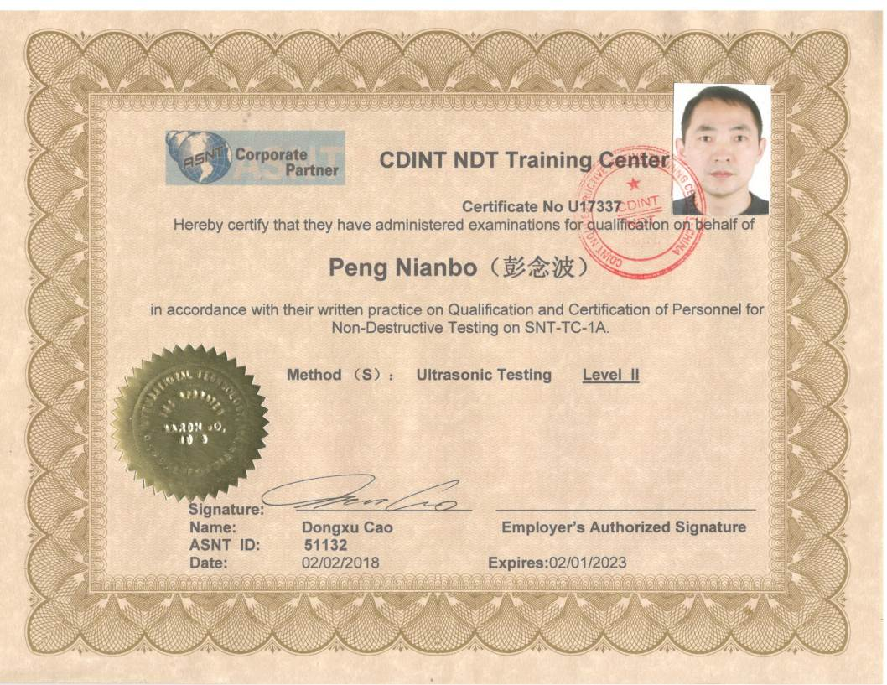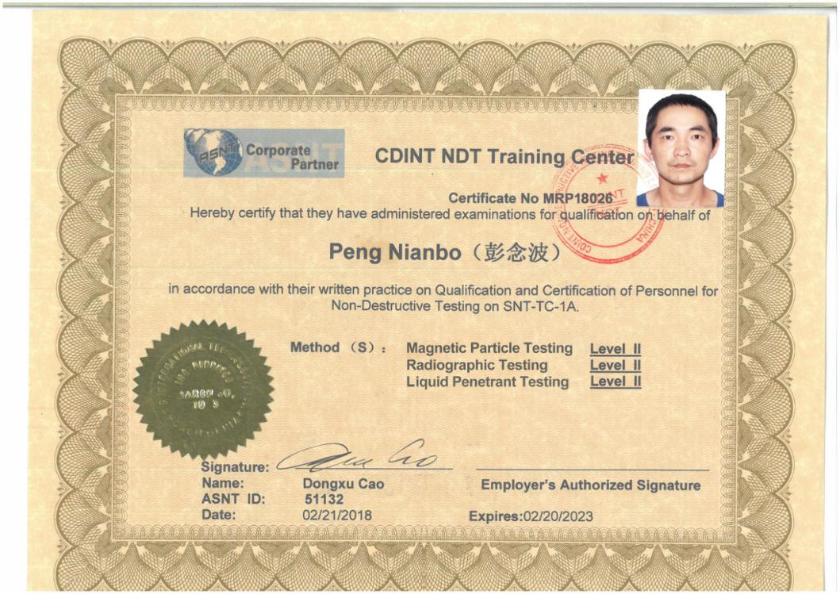

============================== the end ===============================

